Abstract
This microproject focuses on data visualization and analysis using a housing dataset of independent local houses in Vidi Gharkul, Solapur. The dataset contains features such as house price, square footage, number of floors, age of the house, and parking availability.
The project demonstrates how raw housing data can be explored, cleaned, and analyzed before applying machine learning techniques. Exploratory Data Analysis (EDA) is performed to detect patterns, trends, correlations, and outliers. Various visualization techniques such as scatter plots, histograms, box plots, heatmaps, 3D plots, and regression plots are used to interpret the data effectively.
Proper analysis and visualization improve understanding of the dataset and help in selecting important features for predicting house prices. This project highlights the importance of EDA as a strong foundation for building reliable and efficient machine learning models.

Introduction
Data visualization and data analysis play an important role in Machine Learning, especially in real estate price prediction. Before building any prediction model, it is essential to understand the dataset structure and characteristics.
In this project, a housing dataset containing 30 independent houses from Vidi Gharkul, Solapur is created. The dataset includes:
- price_inr
- sqft
- floors
- age_years
- parking
Data visualization techniques such as scatter plots, heatmaps, violin plots, 3D plots, and density plots are used to analyze relationships between features and house prices.
Through proper analysis and visualization, meaningful insights are obtained, which help improve prediction accuracy and decision-making.

Objectives
- To understand the importance of data visualization in house price prediction.
- To create and explore a local housing dataset.
- To perform data cleaning and preprocessing.
- To apply EDA techniques to identify price trends.
- To analyze how house size, age, floors, and parking affect price.
- To detect outliers using box plots and violin plots.
- To visualize feature relationships using scatter plots and heatmaps.
- To study multi-feature relationships using 3D plots.
- To identify important features using regression coefficients.
- To prepare data for machine learning model building.

Methodology
- Data Collection:
A synthetic dataset of 30 independent houses in Vidi Gharkul, Solapur was generated using NumPy and Pandas.
- Data Understanding:
- Checked dataset shape
- Checked missing values
- Used .describe() to get statistical summary
- Data Cleaning:
- Verified missing values
- Removed outliers (top 1% price filtering)
- Confirmed cleaned dataset size
- Exploratory Data Analysis (EDA):
The following visualizations were applied:
- Visualizations Used in Project:
- Scatter Plot with Trend Line:
Shows relationship between sqft and price.
- 3D Scatter Plot:
  - Shows relationship between:
- Square feet
- Age
  - Price
- Box Plot:
Used to detect price outliers.
- Violin Plot:
Shows distribution shape of house prices.
- Heatmap:
  - Shows correlation between:
- sqft
- age
- floors
- parking
- price
- Density Contour Plot:
Shows concentration of houses based on size and price.
- Pair Plot:
Shows relationships between all numerical features.
- Feature Importance Graph:
Using Linear Regression coefficients to see which feature affects price most.
- Feature Selection:
Important features:
- Square feet (strong positive impact)
- Age (negative impact)
- Floors
- Parking
- Data Preparation for ML:
Prepared dataset for Linear Regression model training.

Applications
- Real estate price prediction.
- Property investment analysis.
- Housing market trend study.
- Urban planning and development decisions.
- Bank loan approval evaluation.
- Property valuation for buyers and sellers.

Code with Output
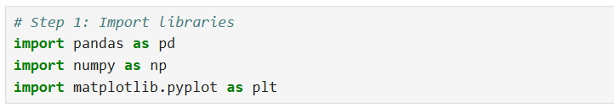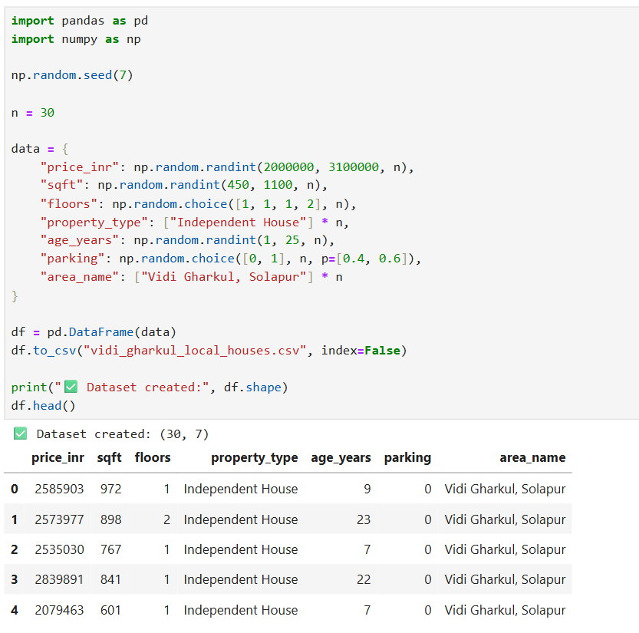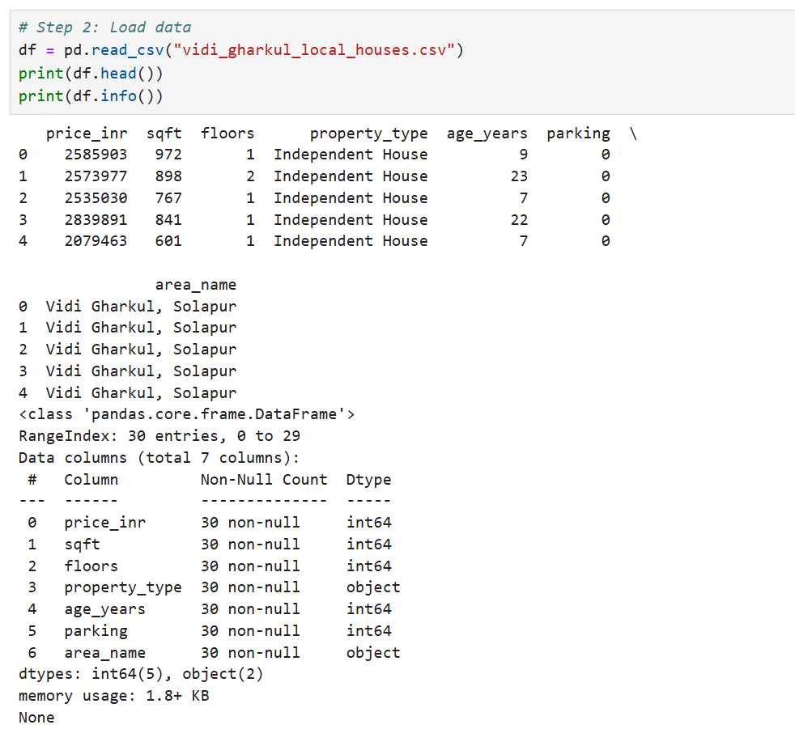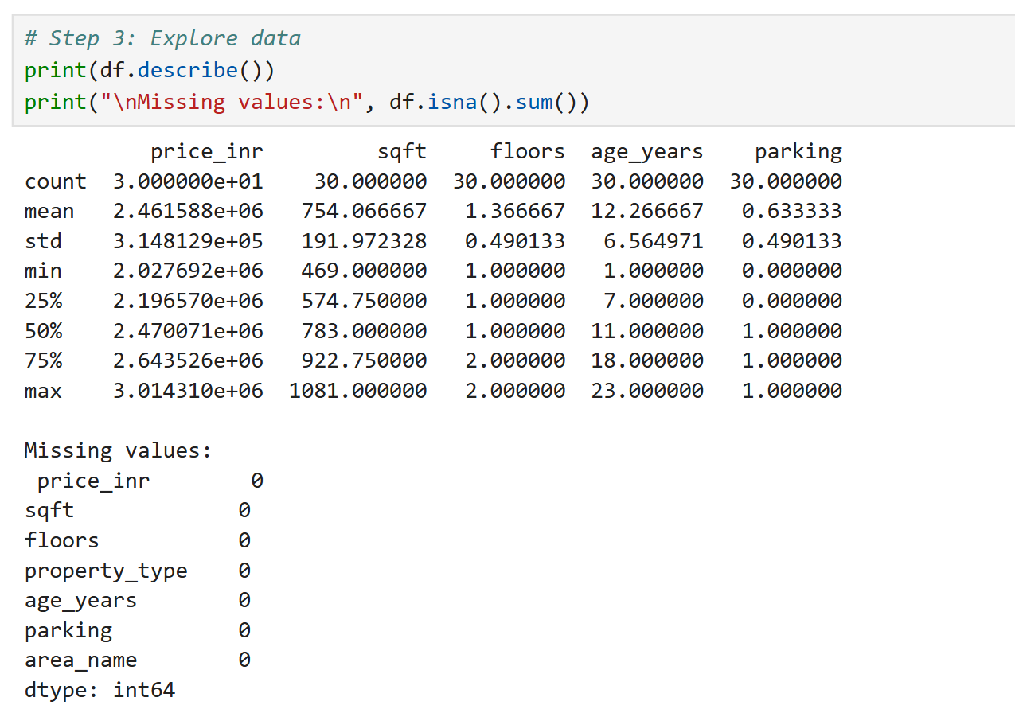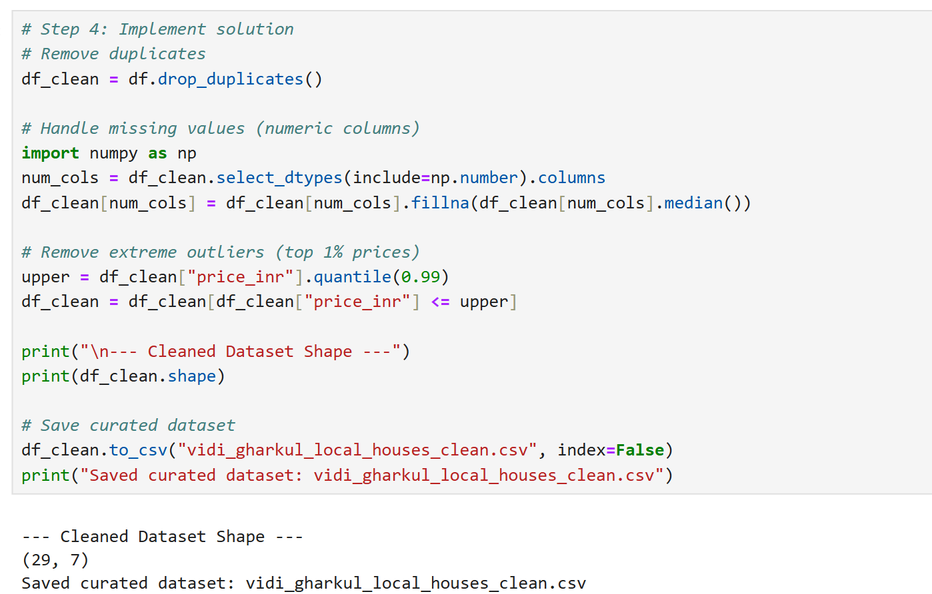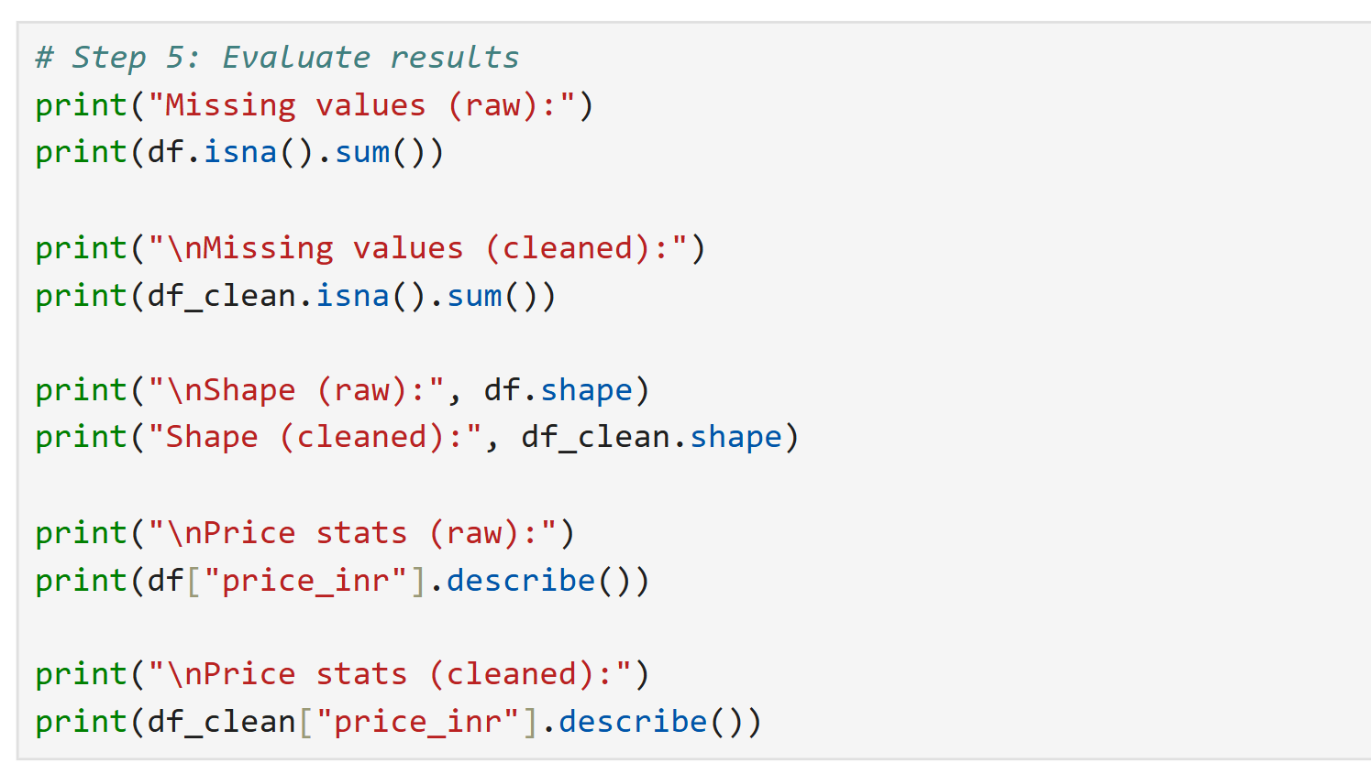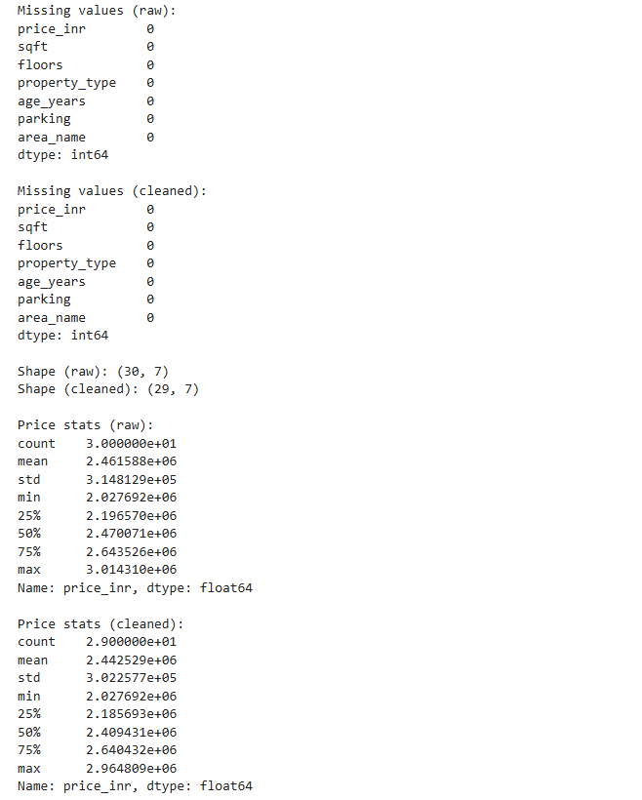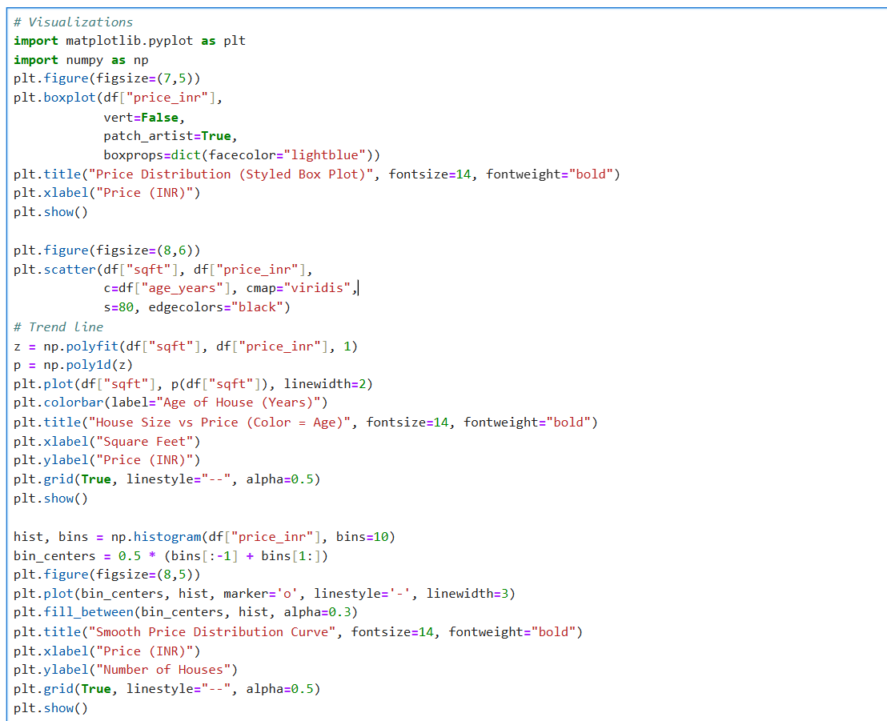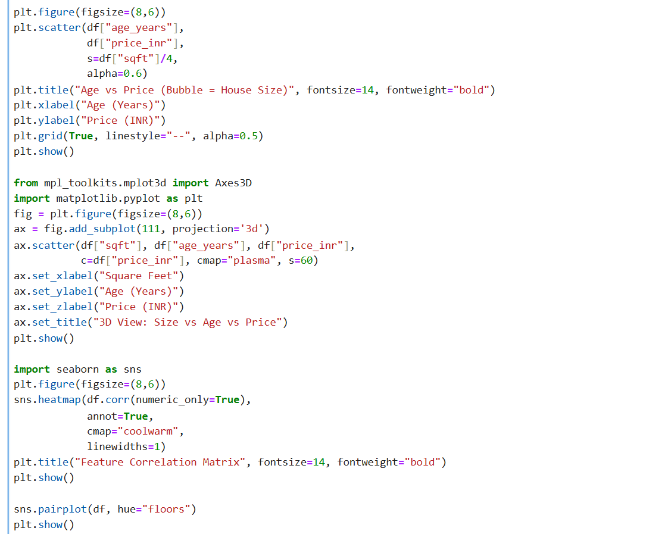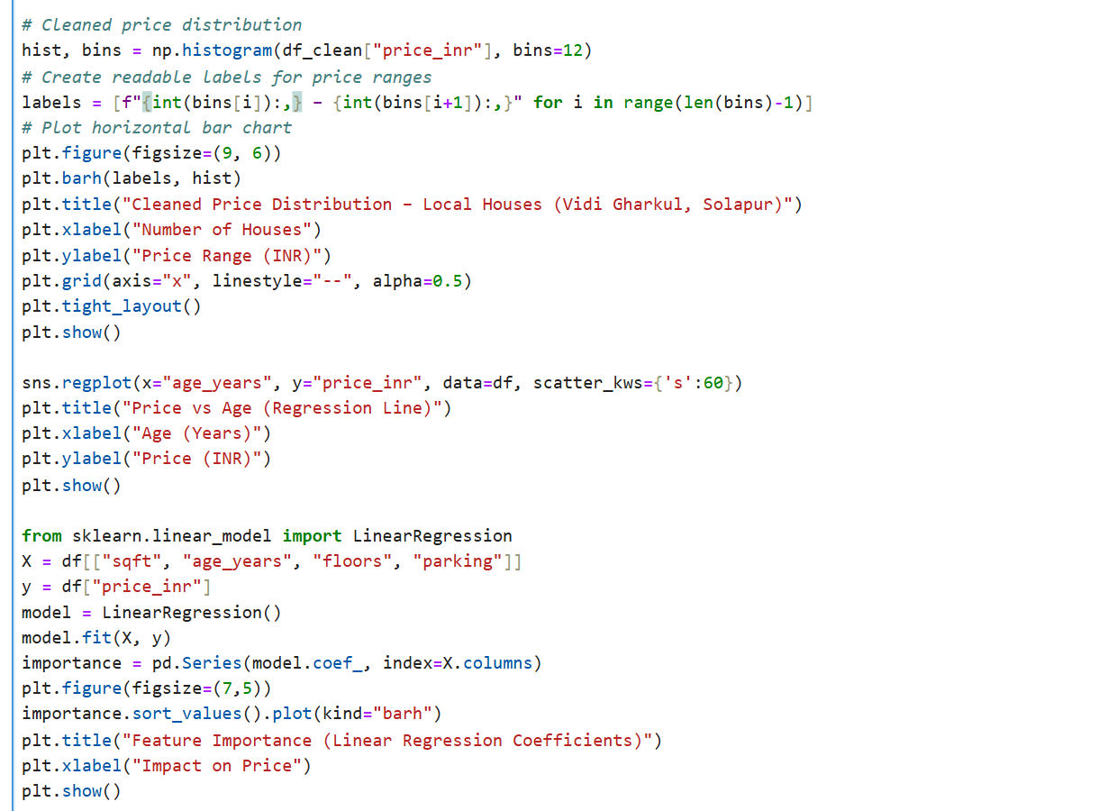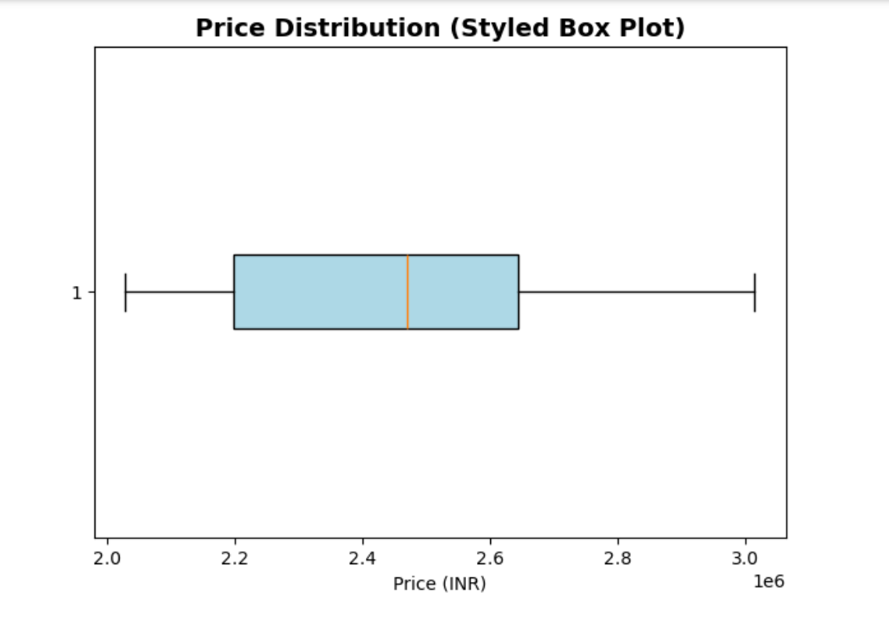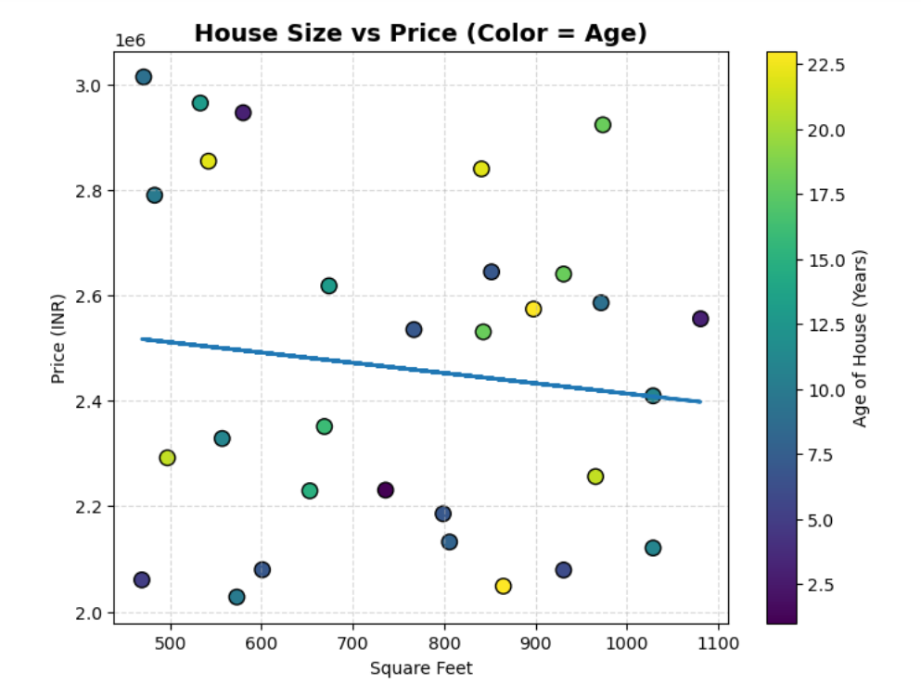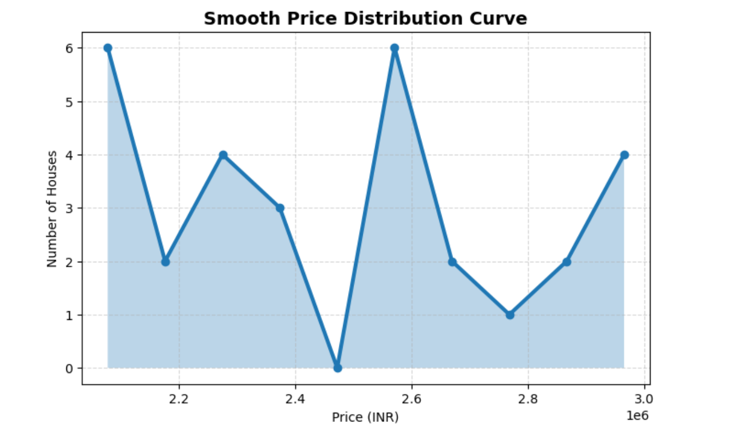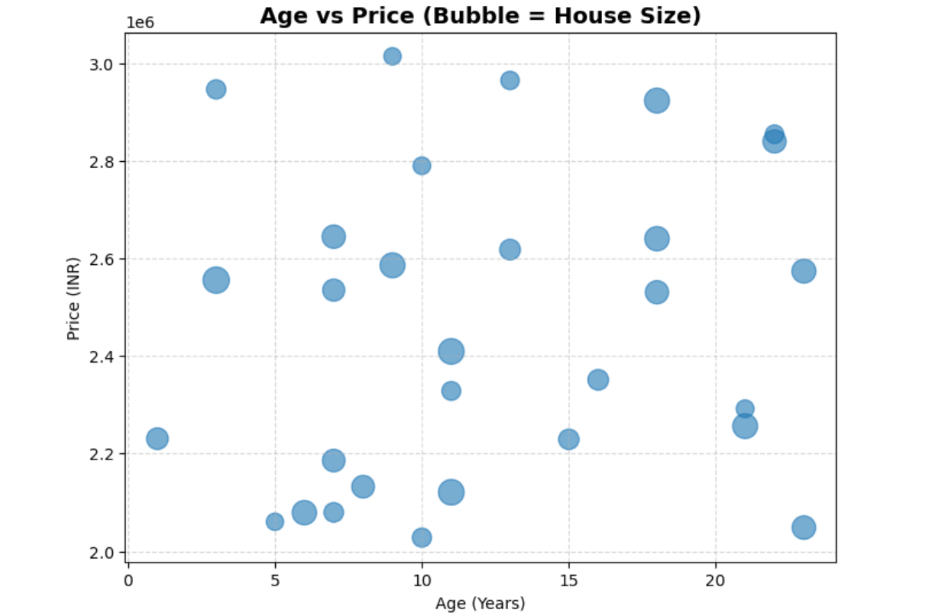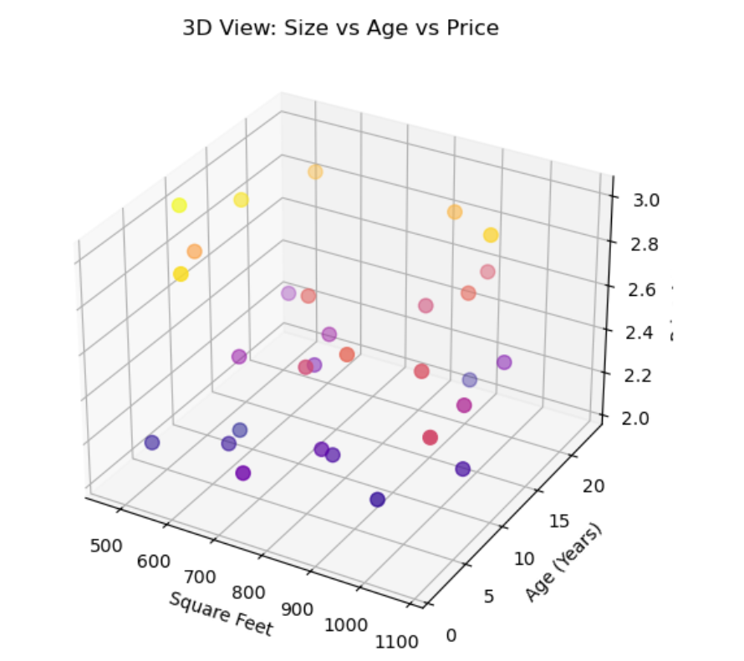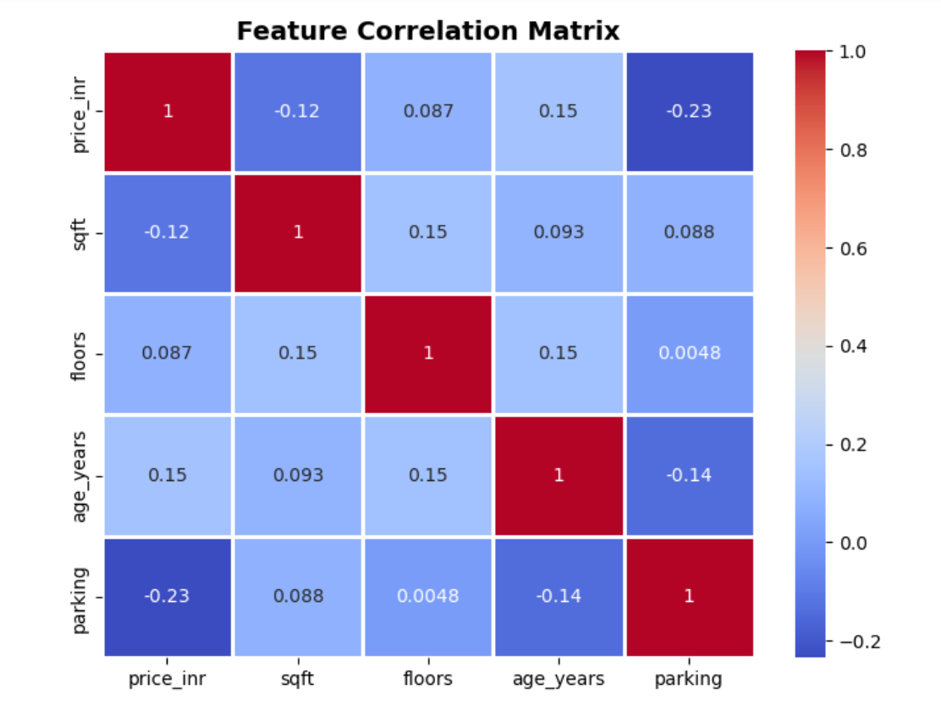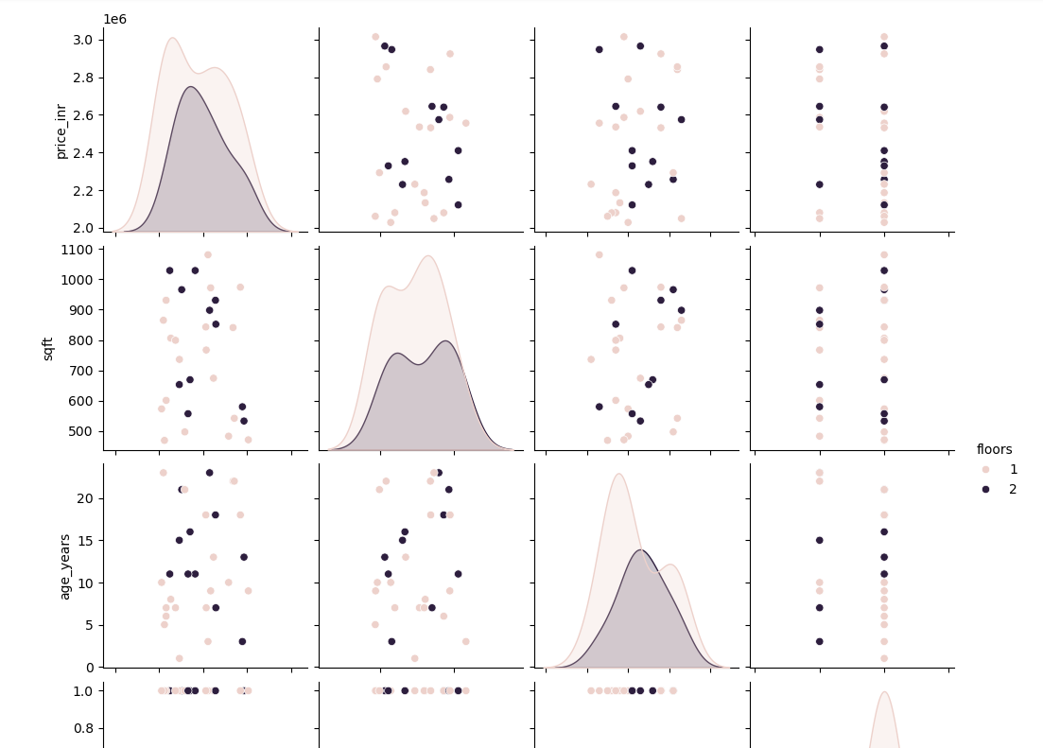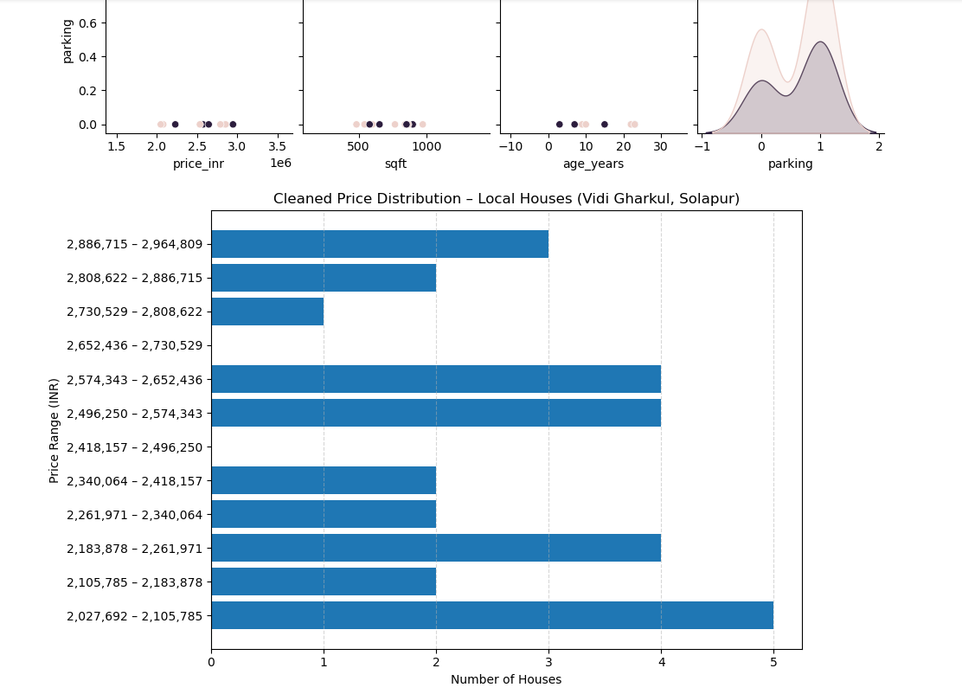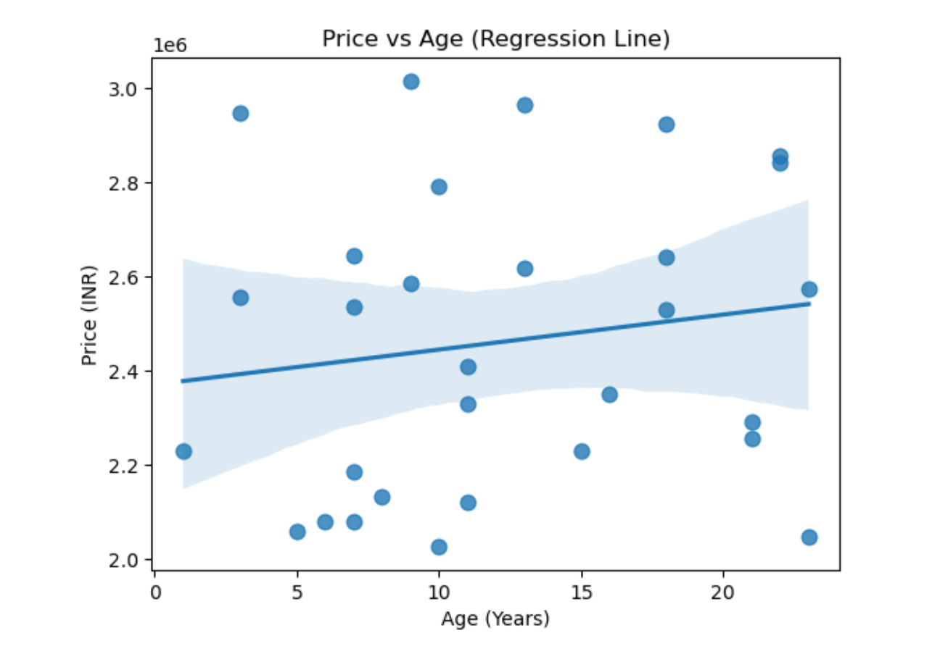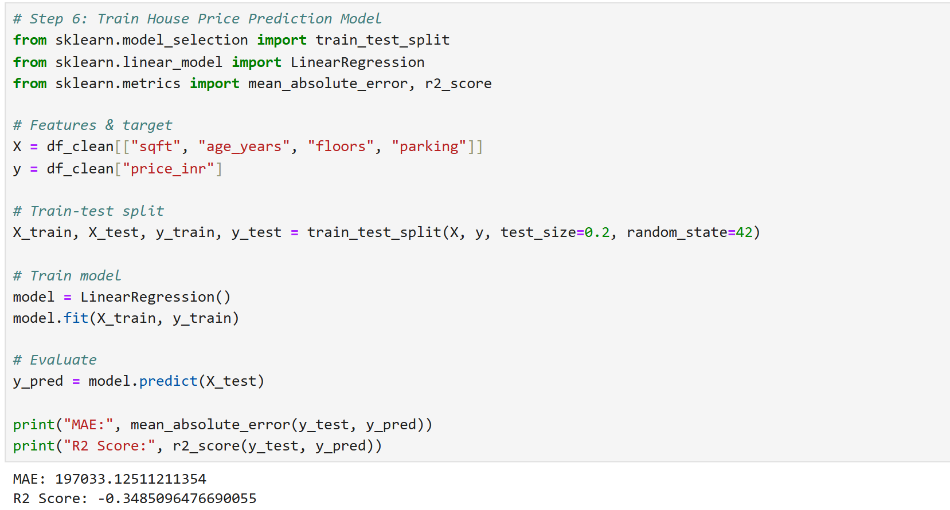

Advantages
- Helps understand local housing price trends.
- Identifies important features affecting price.
- Detects unusual price values.
- Improves model performance.
- Supports better real estate decision-making.
- Makes complex data easier to interpret.
- Provides strong foundation for ML model training.

Conclusion
This project demonstrates the importance of data visualization and analysis in predicting house prices. By analyzing housing data from Vidi Gharkul, Solapur, various patterns and relationships were identified between house features and price.
Visualizations such as scatter plots, heatmaps, violin plots, and 3D plots helped in understanding data distribution and feature impact. Proper data cleaning and feature analysis improved dataset quality and prepared it for machine learning modeling.
Thus, data visualization and analysis serve as a strong foundation for building accurate and reliable house price prediction models.

References
- Scikit-learn Documentation – https://scikit-learn.org/
- Pandas Documentation – https://pandas.pydata.org/
- NumPy Documentation – https://numpy.org/
- Matplotlib Documentation – https://matplotlib.org/
- Seaborn Documentation – https://seaborn.pydata.org/

QR Code

https://github.com/ShravyaPM-00D/MAL-Final-1

